SWAGLABS Project Automation

Contents

Project Overview 2

Prerequisites 2

Installation instructions 3

➢ GitHub Repository 3

➢ Project Setup and execution 5

Project Details 9

Contact information 9

|  |  |  |  |
| --- | --- | --- | --- |
| **Version** | **Date** | **Author** | **Description** |
| **0.1** | **2021-09-10** | **Shreya uttarwar** | **initail draft version** |
| **1** | **2021-09-11** | **shreya uttarwar** | **finalised document** |
|  |  |  |  |

# **Project Overview**

**The project consists of test automation of SwagLabs application.**

**It has been is created for Global Kinetic between 07-09-2021 and 13-09-2021. Technologies used to create the project are**

* **Selenium – Java**
* **Cucumber**
* **Gherkin**
* **Maven**
* **Extent Reports**
* **BDD framework**

# **Prerequisites**

**Below are the prerequisites for configuration of the project**

* **Java 8+**
* **Eclipse**
* **Maven**
* **GitHub Account**
* **GitHub Desktop**

# **Installation instructions**

## **GitHub Repository**

1. To access project source code, go to below link:

<https://github.com/uttarwarshreya/SauceLabs_Automation>

1. Click on fork and it should create a forked repository for logged in Git user.

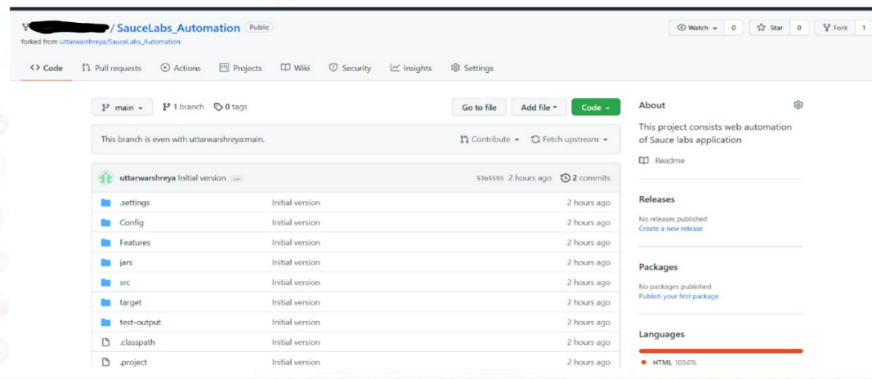

1. Click on Code button and copy the repository path

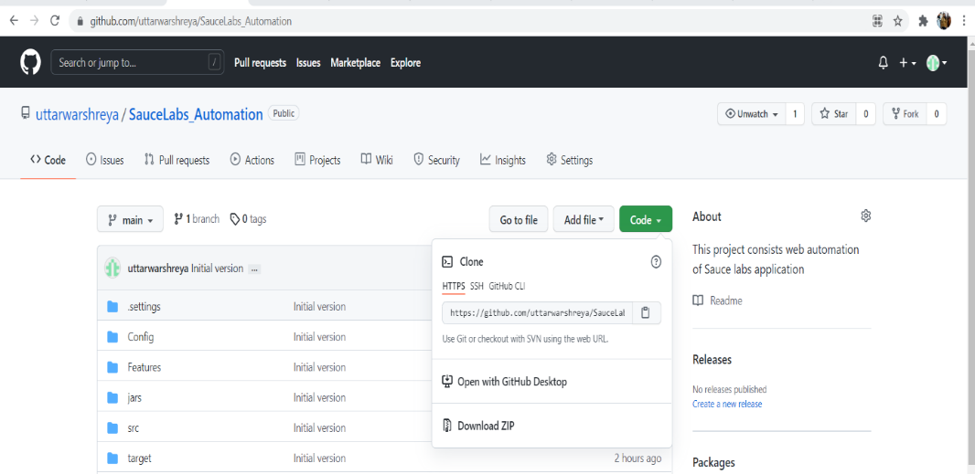

1. Open GitHub desktop and select clone repository from file menu

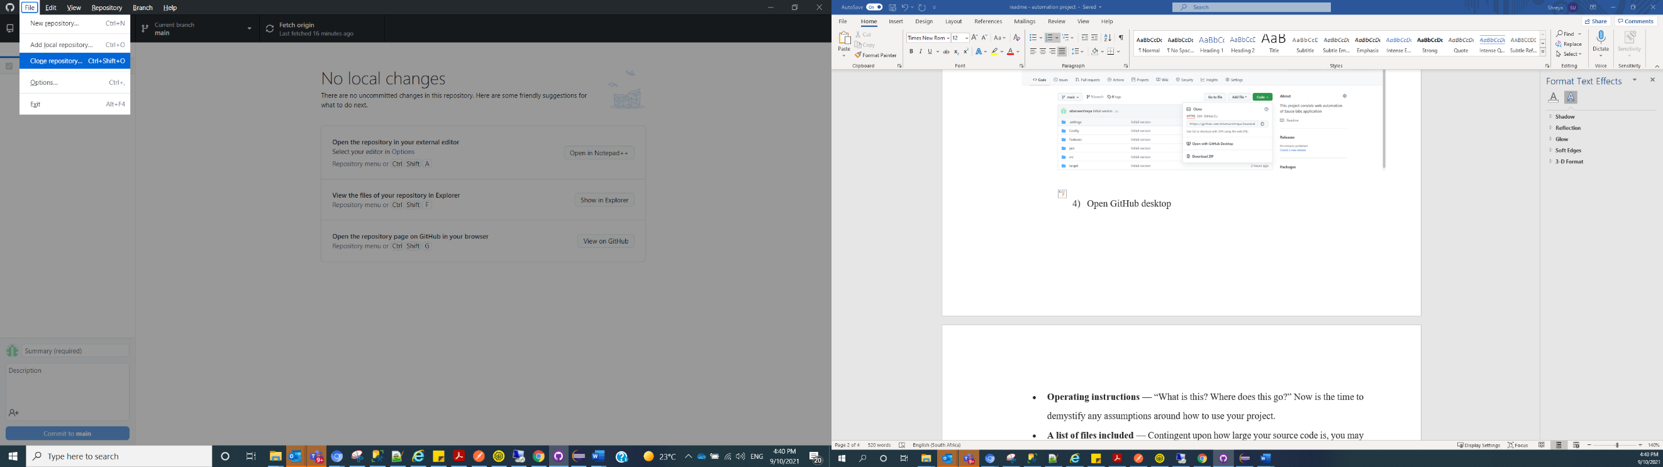

1. **Under URL tab enter copied URL in Repository URL textbox and select local path where you want to save the repository locally on your machine. Click on Clone button**

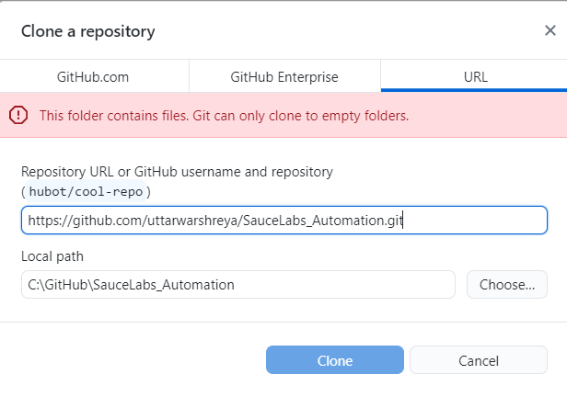

1. **Repository should be created on your local machine**

## **Project Setup and execution**

1. **Open eclipse and create a workspace**
2. **Import the project cloned from GitHub by specifying the local path**

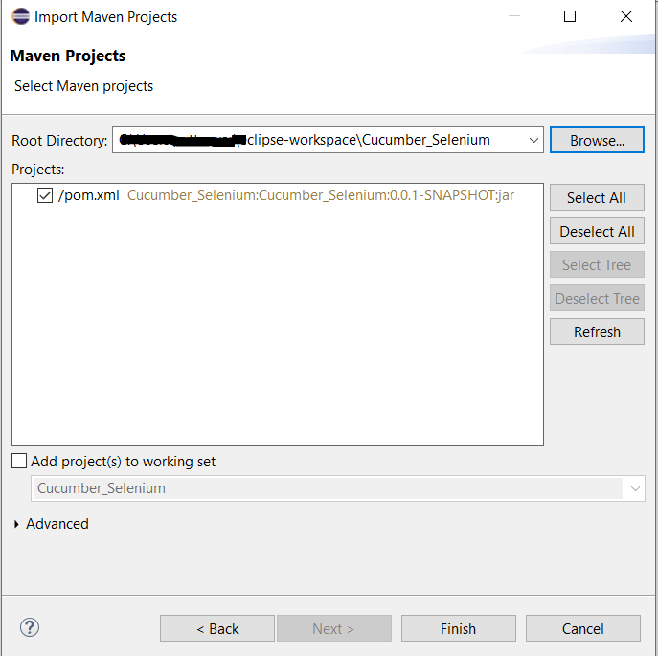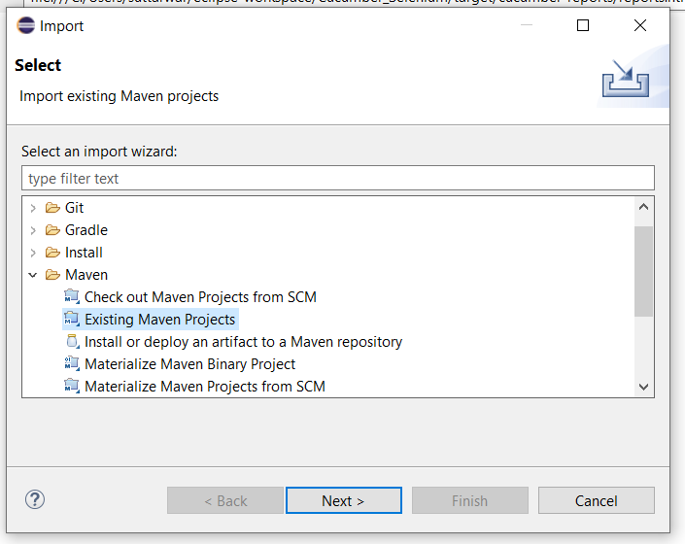

1. **Project should be imported**

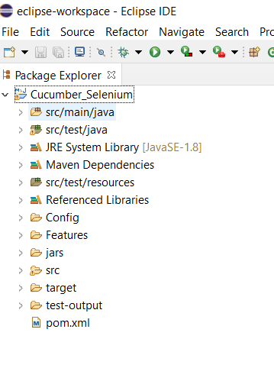

1. **Right click on project and select Run As -> Junit Test**

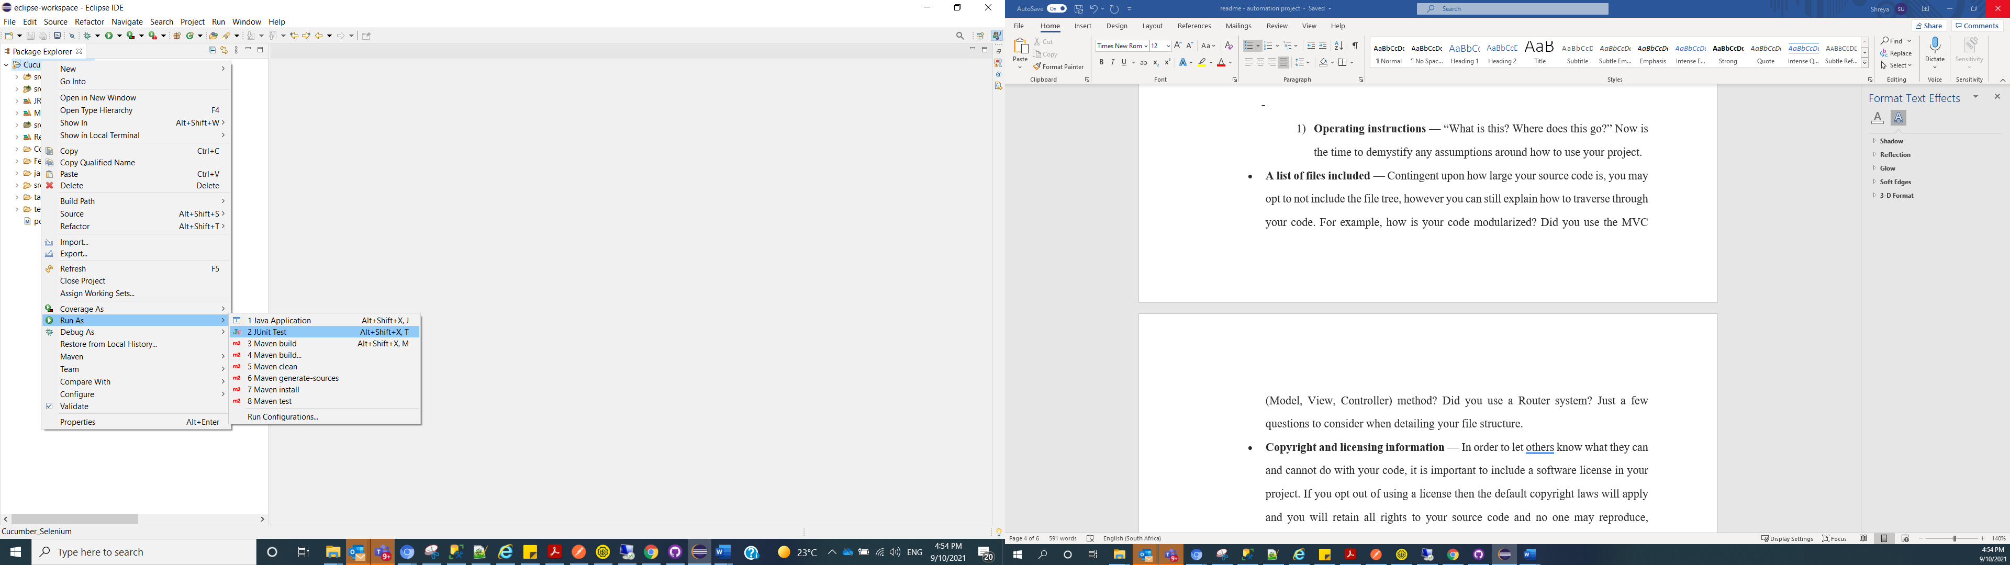

1. **Test case execution should start (This may take approximately 2 minutes)**

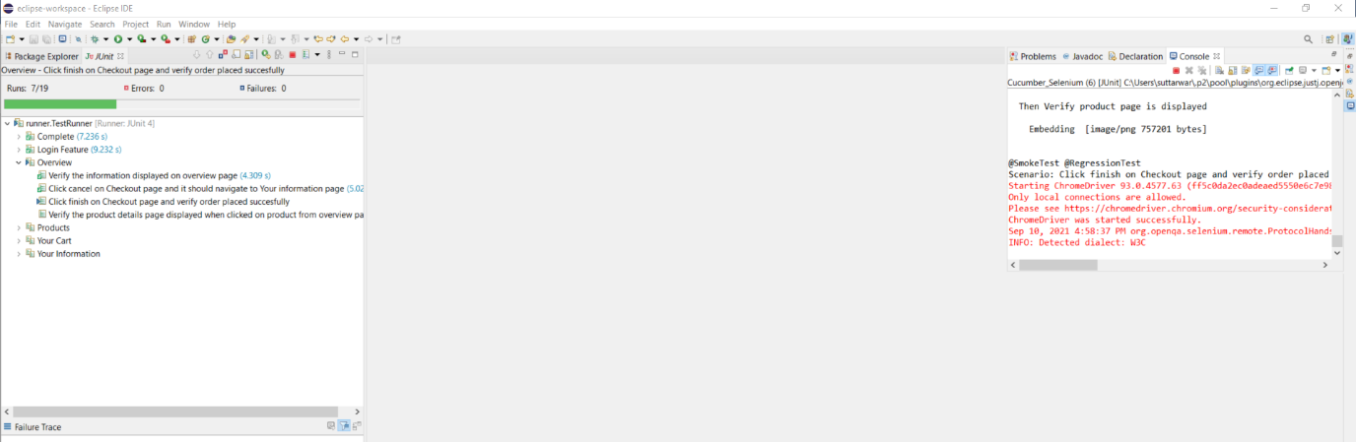

1. **Once execution completed user will be able to see as below execution summary**

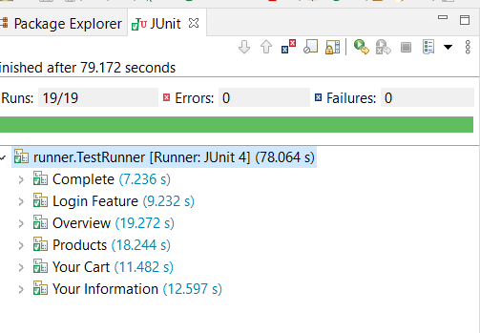

1. Once execution is completed an extent report will be created which will be stored in below location in user’s local machine

{project directory path}\Cucumber_Selenium\target\cucumber-reports\advanced-reports\extentreports

1. 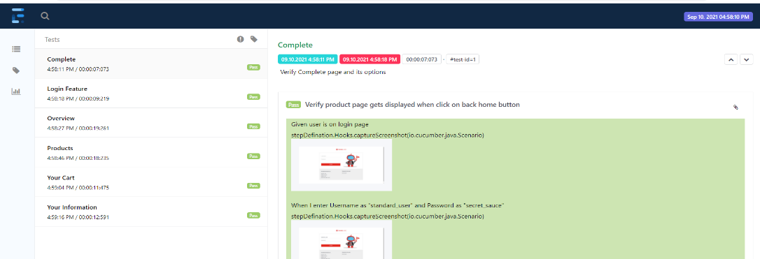Open report.html file which includes execution details with screenshots.

# **Project Details**

* **The project has been created using BDD framework which gives user capability to write test scenarios using cucumber/Gherkin language. To achieve this different feature files are created under ‘Features’ folder.**
* Maven architecture has been used to accommodate the dependencies like selenium, gherkin, cucumber etc under ‘pom.xml’
* Selenium code is available at ‘\src\test\java’ under the project.
* Test execution can be controlled from ‘TestRunner.java’ file which is under ‘\src\test\java’ folder.
* Hooks and tags are used in the project to maintain the execution flow and selection of test cases.
* All the elements are mentioned in ‘ElementProperties.java’ file which are referenced throughout the project.

# **Contact information**

* Name : Shreya Uttarwar
* Email : [uttarwarshreya@gmail.com](mailto:uttarwarshreya@gmail.com)
* Mobile : 0847304410
* LinkedIn : <https://www.linkedin.com/in/shreya-uttarwar-62b80161/>